Jenkins Task 01

INSTALL JENKINS AND RUN JENKINS ON PORT NUMBER 8081.
- Go to aws console login
- Lauch instance connect to instance

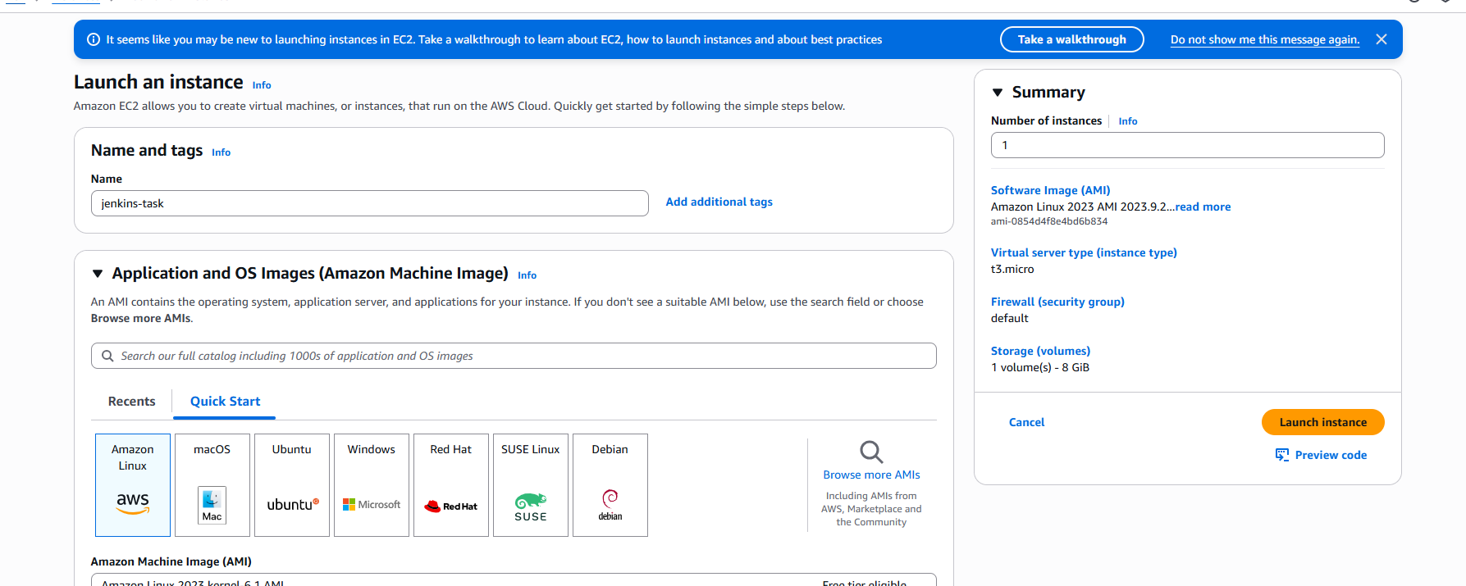
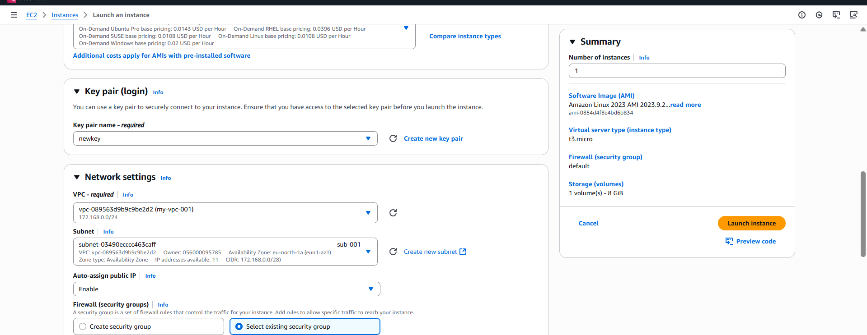
- Insall Jenkins go to Jenkins official website : https://www.jenkins.io/ downloadredhatuse the commands shown in the steps
- Jenkins dependencies is java ,install java also.
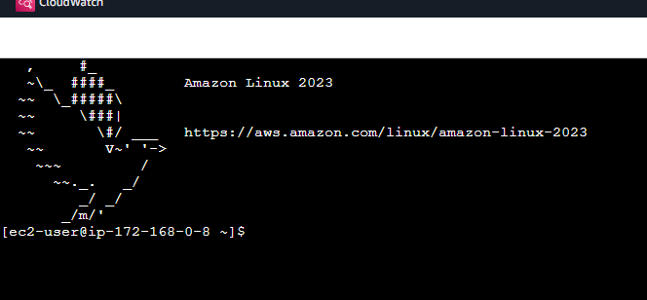
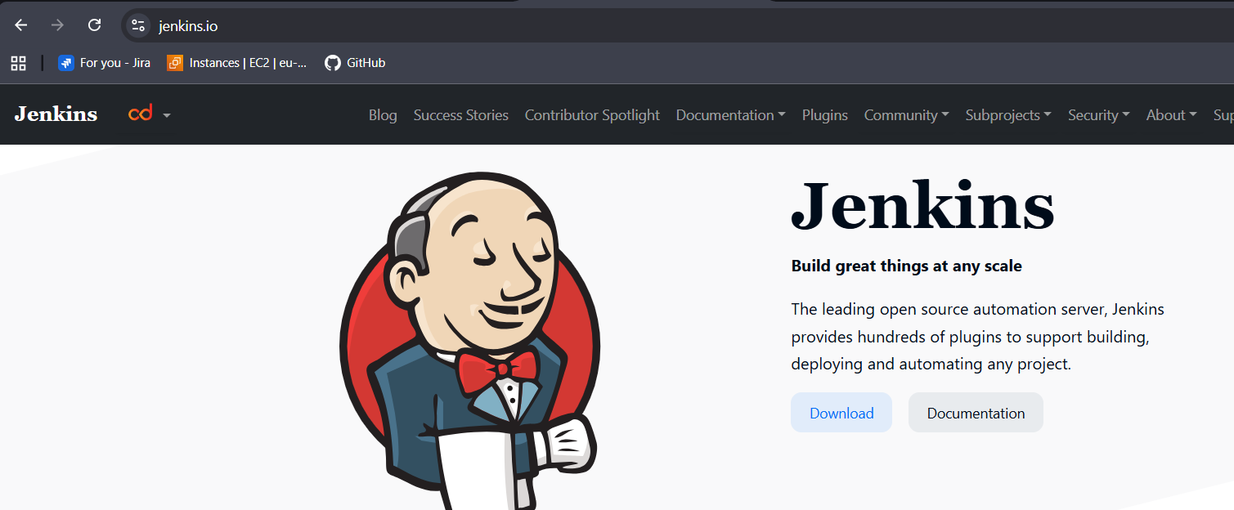
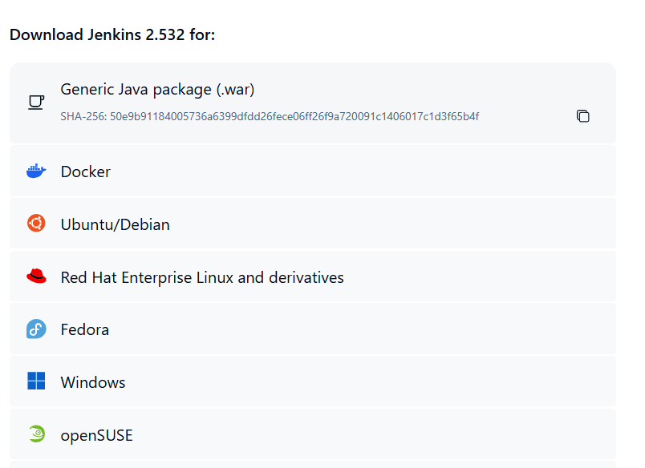

- sudo wget -O /etc/yum.repos.d/jenkins.repo \
https://pkg.jenkins.io/redhat/jenkins.repo
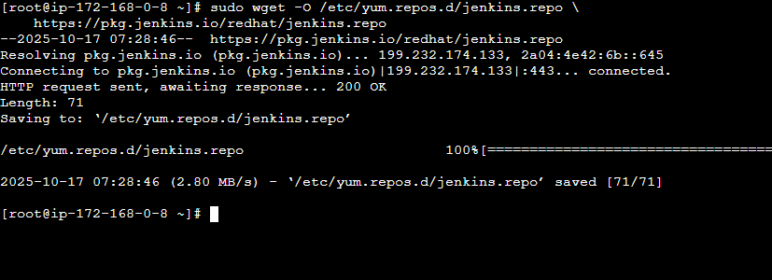
- sudo rpm --import https://pkg.jenkins.io/redhat/jenkins.io-2023.key
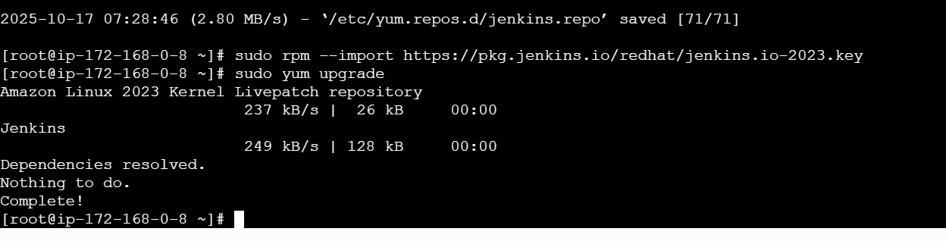
- sudo yum upgrade
- # Add required dependencies for the jenkins package
- sudo yum install java-21

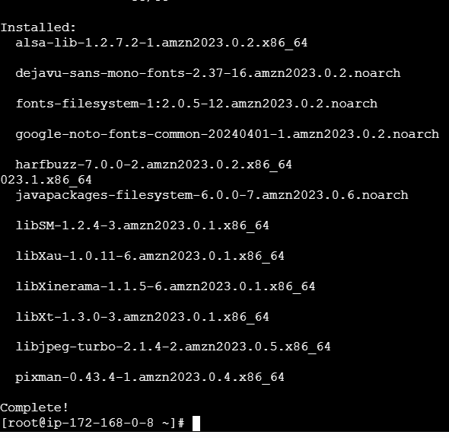
- sudo yum install jenkins
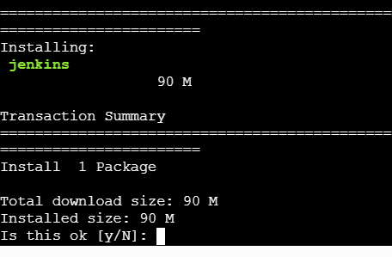
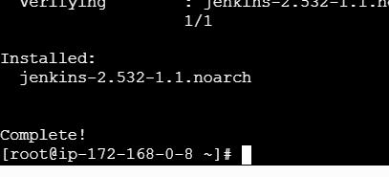
- check by using browser : <ipv4-adress>:8080
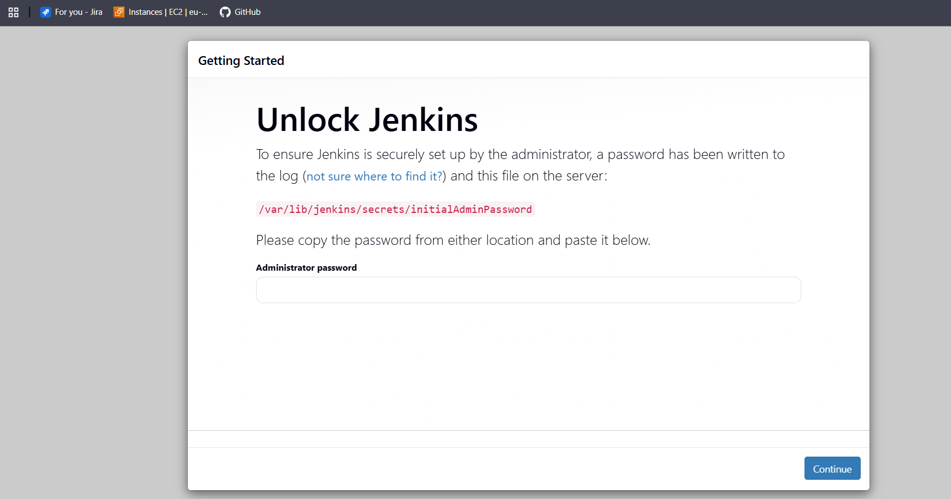
- to change port number go to Jenkins.service file
- find / -name jenkins.service
- vi Jenkins.service
- PORT LISTEN=8081—change it to 8081
- Save and exit - :wq!
- Systemctl daemon-reload
- Systemctl restart jenkins

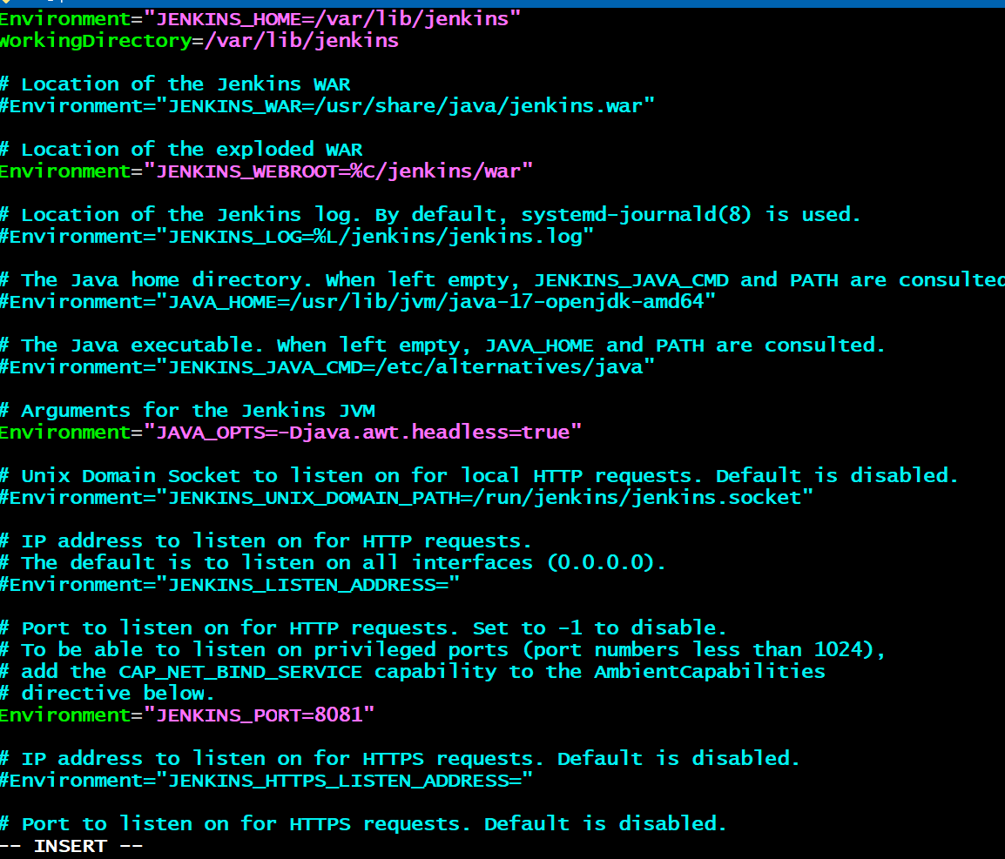
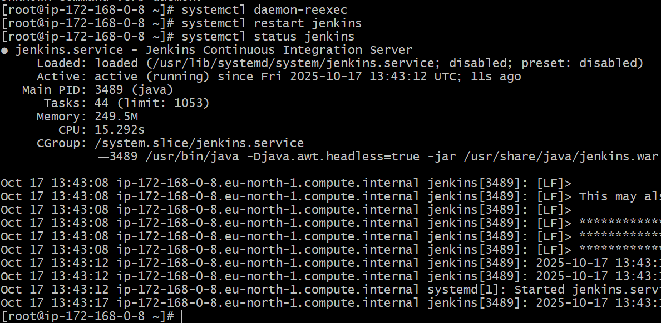
- Check it in your browse - <ipv4-adress>:8081
- Jenkins is running on port 8081
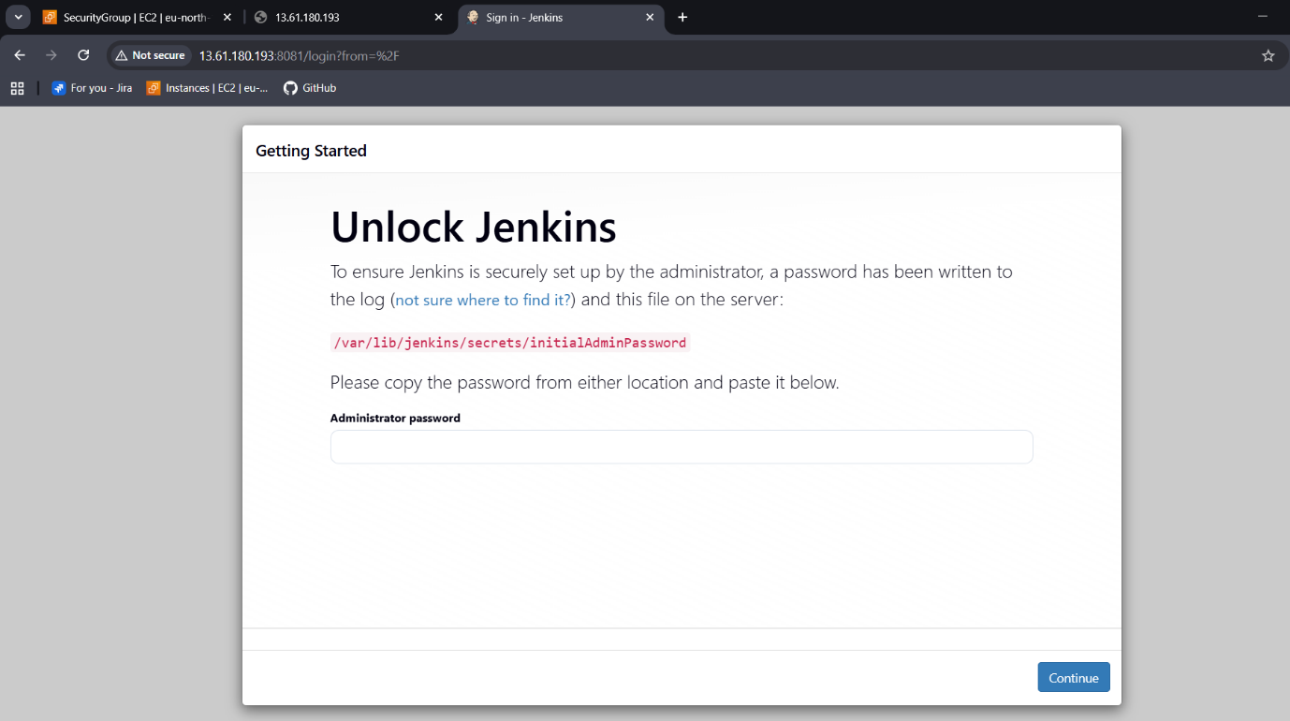

Secure Jenkins server
- Connect to Jenkins login using password
- Password you can find in : cat /var/lib/jenkins/secrets/initialAdminPassword
- Copy and paste to login to your Jenkins server

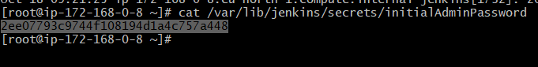
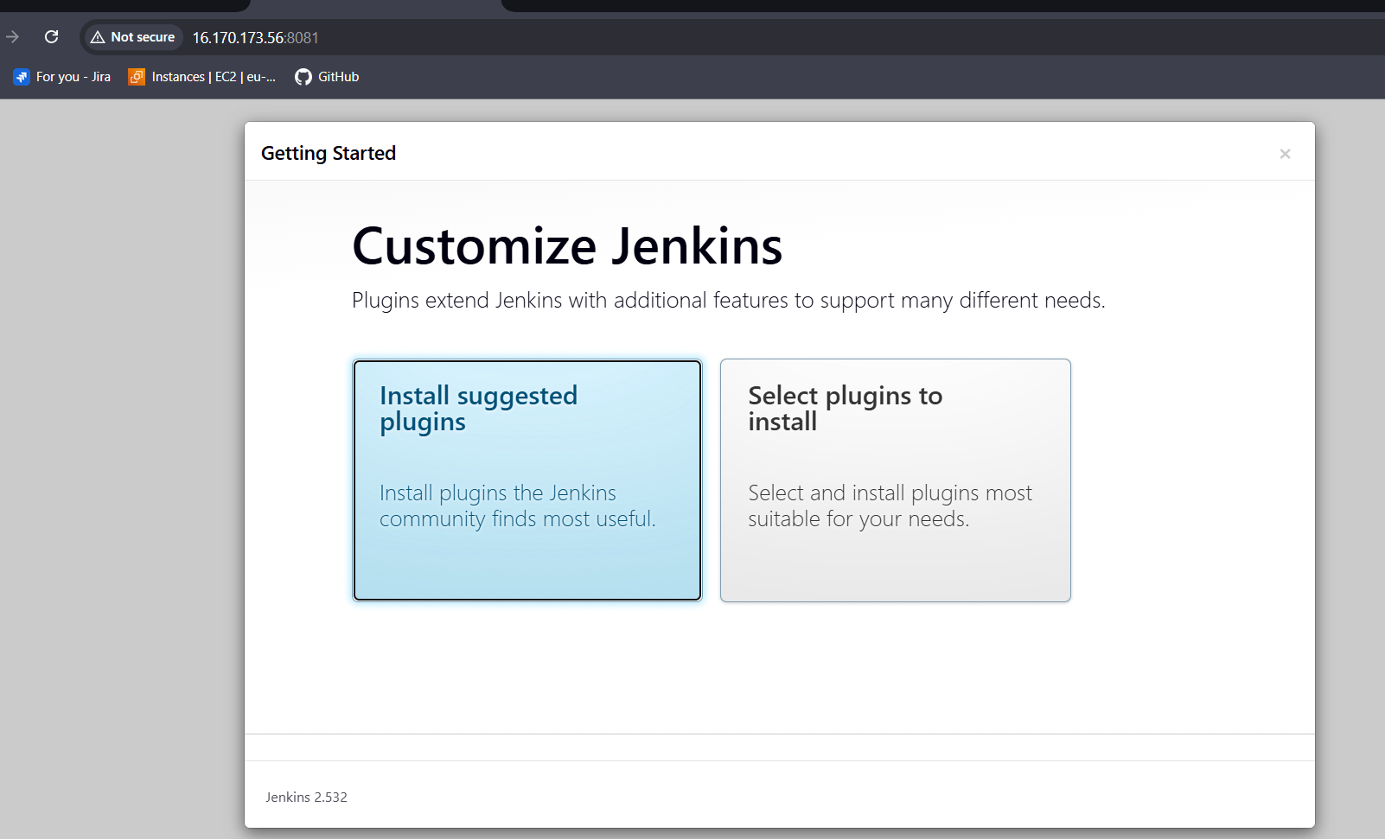
- Create your own admin user and password to secure your Jenkins server.
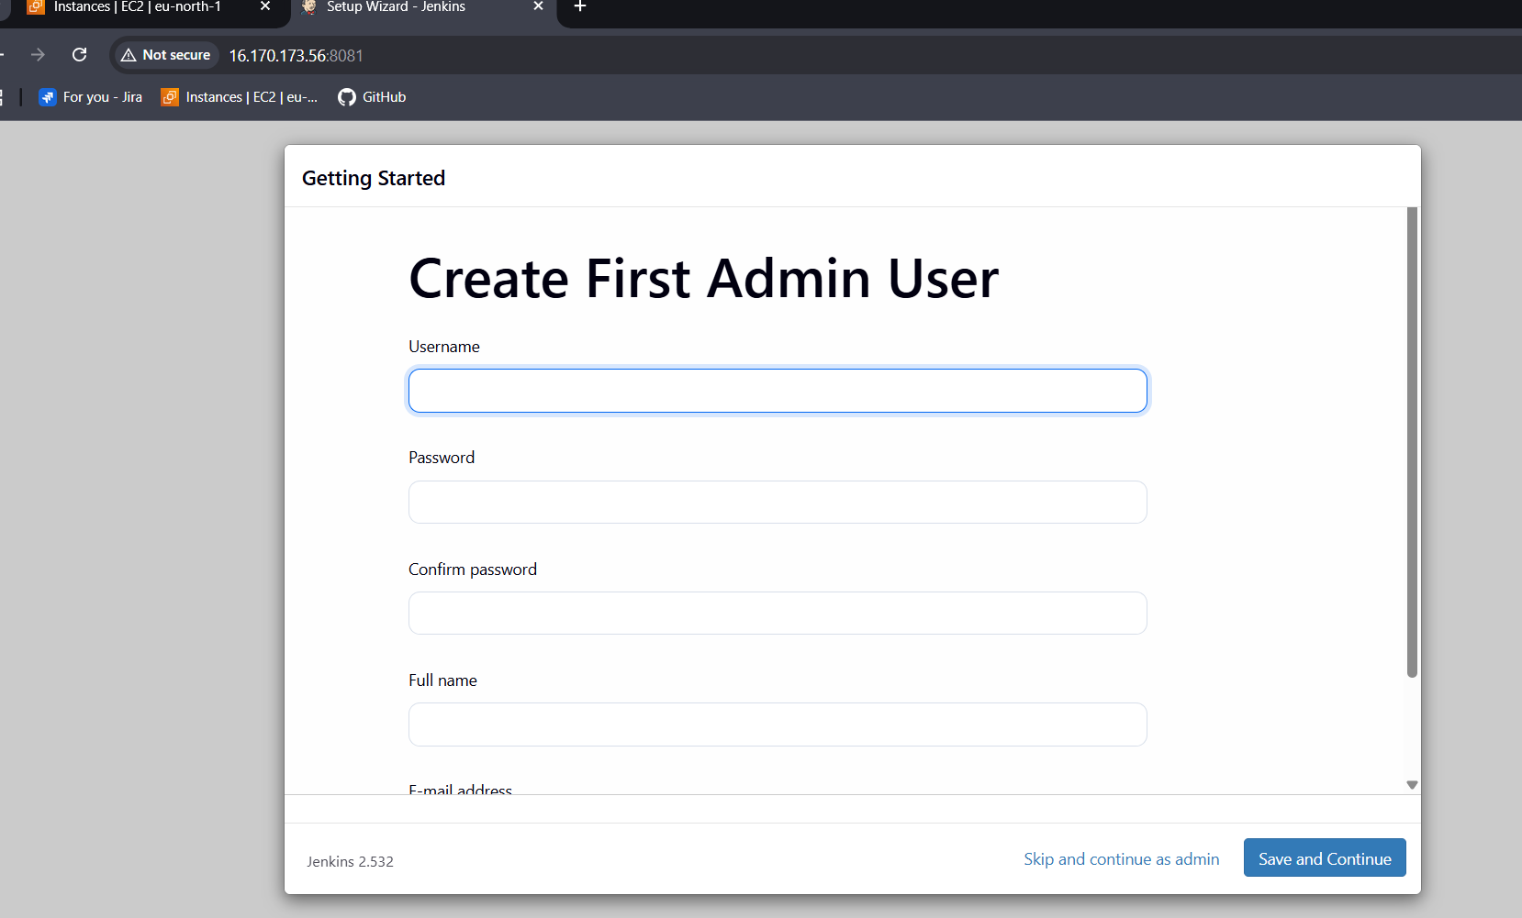
Save and continue.

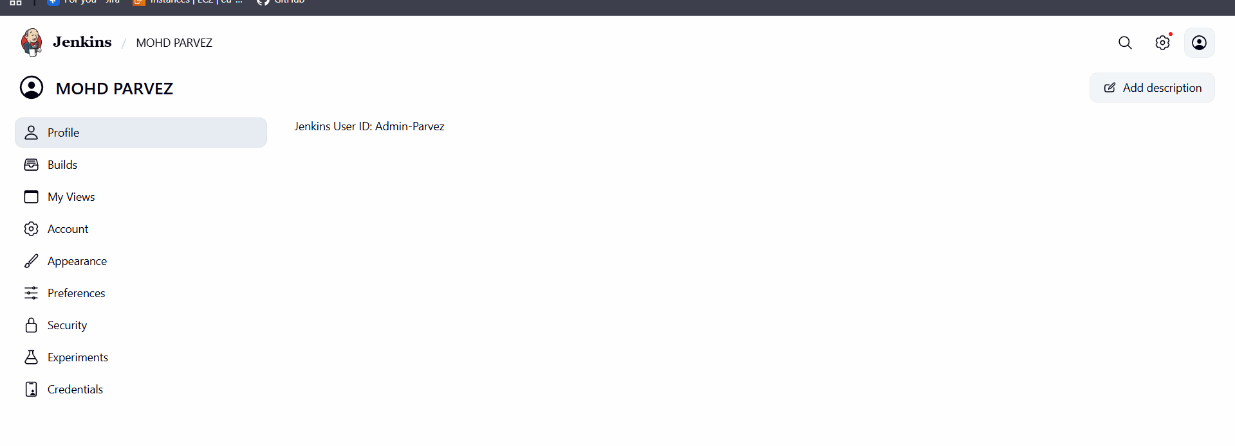

Create users called DevOps, Testing in Jenkins with Limited access.
- Go to settings userscreate users
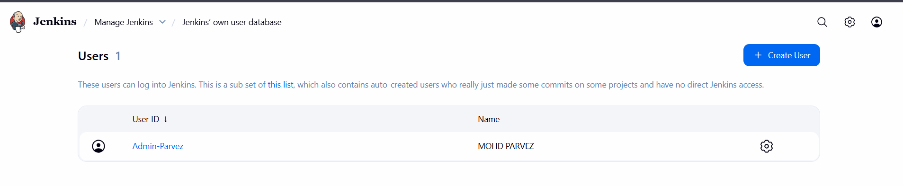
- Create user and password and provide the acess to the specific processes to do

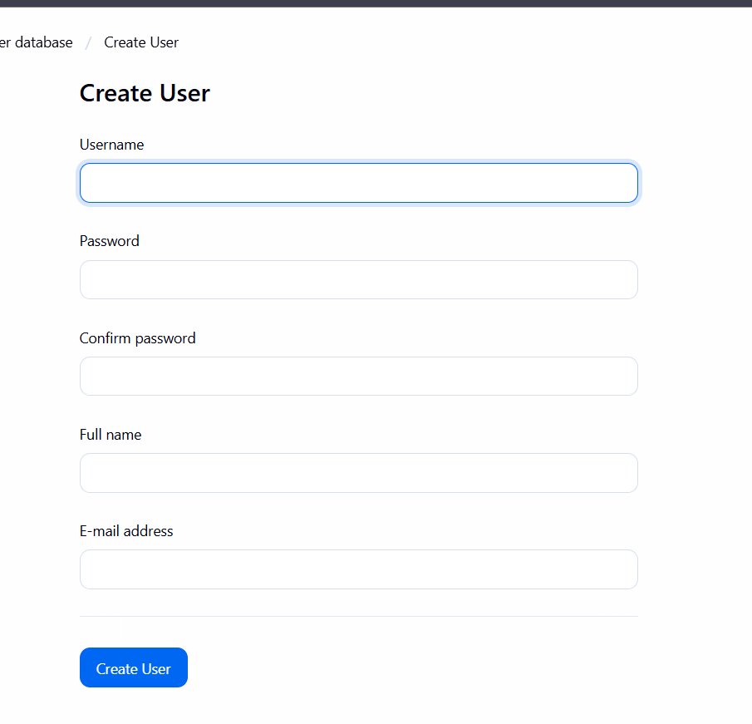
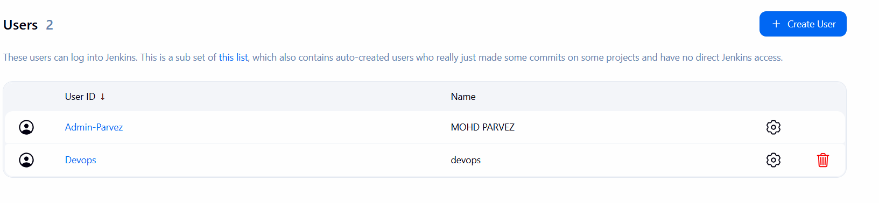
- Similarly create another user with name testing
- We hav created 2 users with name devops and testing
- Now give limited acess to the users with required permissions.

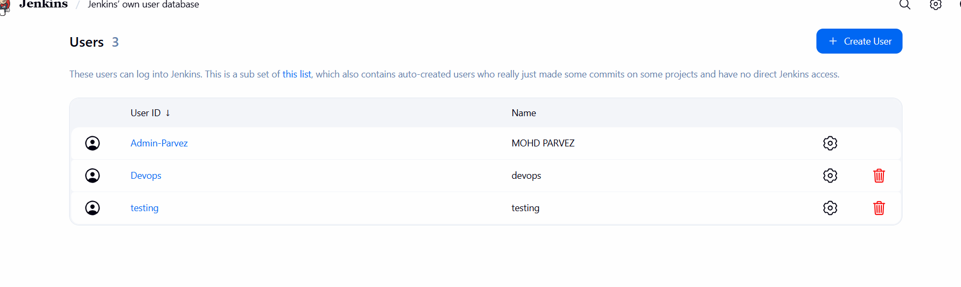

Configure labels and restrict the jobs to execute based on label only.
- Go to manage Jenkins first.
- Then go to plugins >> nd available plugins >> node label parameter >> install.
- Then in manage Jenkins >> node > check the node.
- Then go to the dashboard >> create job >> gave a URL
- its shows you error first.
- Then connect to the your instance nd check the git version.
- If its not available then use “yum install git -y”
- Then the error will gone.
- If is showing some error.
- Click the job nd check error in console output:
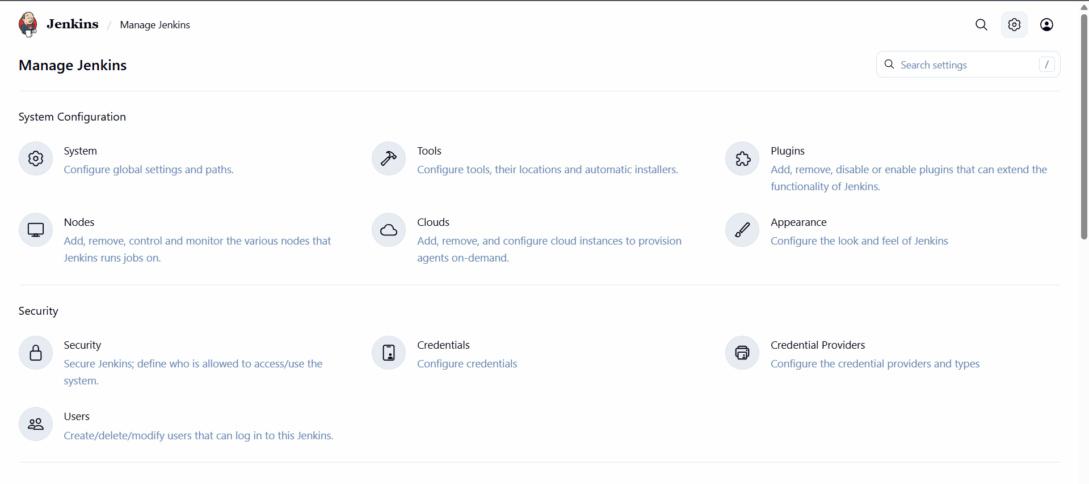
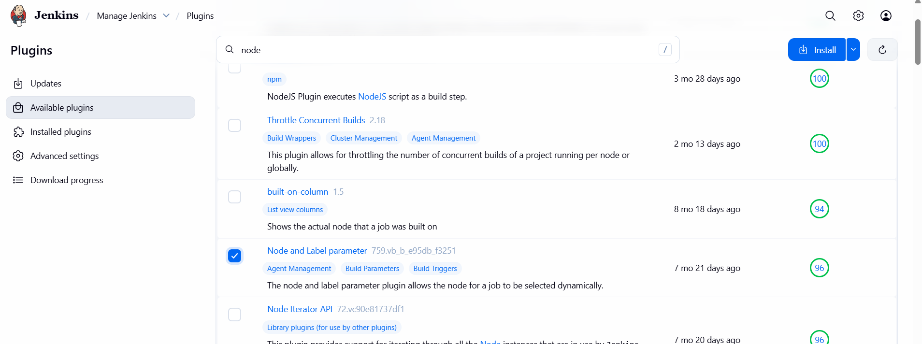
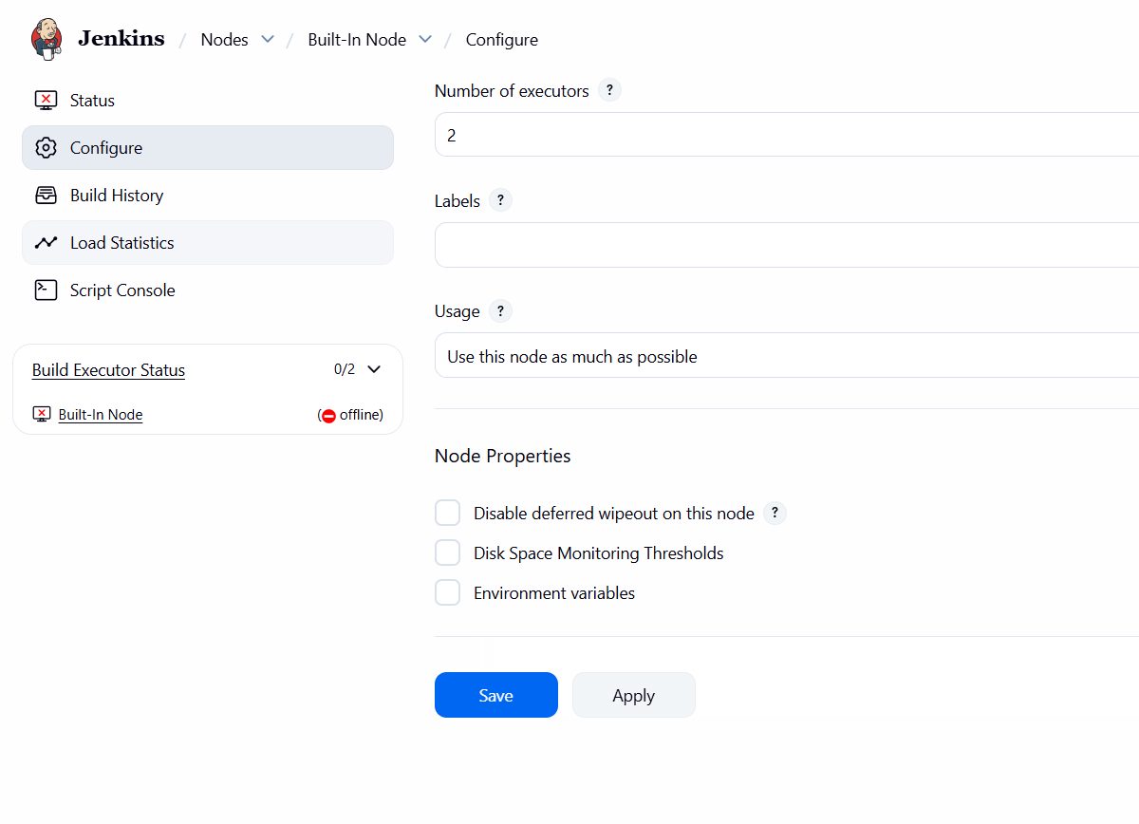

Create Three sample jobs using the below URL. https://github.com/betawins/Techie_horizon_Login_app.git

Create one Jenkins job using git hub Private repository.

